

ذ
REPUBLIC OF YEMEN
SANA'A UNIVERSITY
FACULTY OF ENGINEERING
MECHATRONICS ENGINEERING DEPARTMENT

Battery charging using CC and CV

Done by:
Hassan Moqbel Morshed 202274198
Musa AL_salmani 202174202
Hamza Al-Khalaf 202274127
Systems (parallel).
Supervised by:
Dr. Radwan Al-Budhaji
ENG. Amjed AL_shagthah

Contents
1. Introduction 3
2. Objectives 4
3. Theory 4
4. Circuit Diagrams 6
5. Observations 7
6. Analysis 7
7. Calculation 8
8. Conclusion 9

- Introduction
There are three common methods of charging a battery: constant voltage, constant current and a combination of constant voltage/constant current with or without a smart charging circuit.

Constant voltage allows the full current of the charger to flow into the battery until the power supply reaches its pre-set voltage. The current will then taper down to a minimum value once that voltage level is reached. The battery can be left connected to the charger until ready for use and will remain at that “float voltage”, trickle charging to compensate for normal battery self-discharge. A typical example would a low cost auto battery charger for home use or basic back up power systems. This method enables fast charging rates and is suitable for lead acid types, but not for Nickel Metal Hydride (Ni-MH) or Lithium-Ion (Li-ion) types.

Constant current is a simple form of charging batteries, with the current level set at approximately 10% of the maximum battery rating. Charge times are relatively long with the disadvantage that the battery may overheat if it is over-charged, leading to premature battery replacement. This method is suitable for Ni-MH type of batteries. The battery must be disconnected or a timer function used once charged.

Constant voltage / constant current (CVCC) is a combination of the above two methods. The charger limits the amount of current to a pre-set level until the battery reaches a pre-set voltage level. The current then reduces as the battery becomes fully charged. This system allows fast charging without the risk of over-charging and is suitable for Li-ion and other battery types.

Charging stages:
First Stage: DC Charging:
Charging starts with constant current until the battery reaches a certain.

voltage level.
Second Stage: Continuous Voltage Charging:
Maintains a constant voltage while gradually decreasing the current until it reaches a low level, indicating that charging is complete.

Smart charging involves the use of a micro-controller to compensate for temperature rise and adjust the charge current and charge time accordingly to the battery specifications. This extends battery life and is used with Li-ion battery types. This battery management circuit or unit can be fitted externally to the charger. A number of the power semiconductor manufacturers offer control circuits to perform this function.

- Objectives

. Simulate the charging process of batteries using constant current and voltage.
. Analyze performance and understand system behavior during charging.

- Theory

i. Constant Current Charging.

1. Concept:
- A constant current is connected to the battery throughout the charging period.
- The current does not change although the voltage changes over time.

2. Benefits:
- Reduces charging time compared to other methods.
- Ensures the delivery of a specified and constant amount of power to the battery.

3. Usage:
- Used in the early stages of charging batteries, especially when the battery is empty or almost empty.

ii. Constant Voltage Charging.

1. Concept:
- A constant voltage is maintained while the current changes.
- The current starts high when the battery is empty and then gradually decreases as the battery fills up.

2. Benefits:
- Protects the battery from overcharging.
- Allows the battery to reach its maximum capacity without exceeding the specified voltage.

3. Usage:
- Used in the final stages of charging, when the battery is close to full

iii. Combining current and constant voltage
. Charging starts with constant current until the battery reaches a certain voltage level.
. Maintains a constant voltage while gradually decreasing the current until it reaches a low level, indicating that charging is complete.
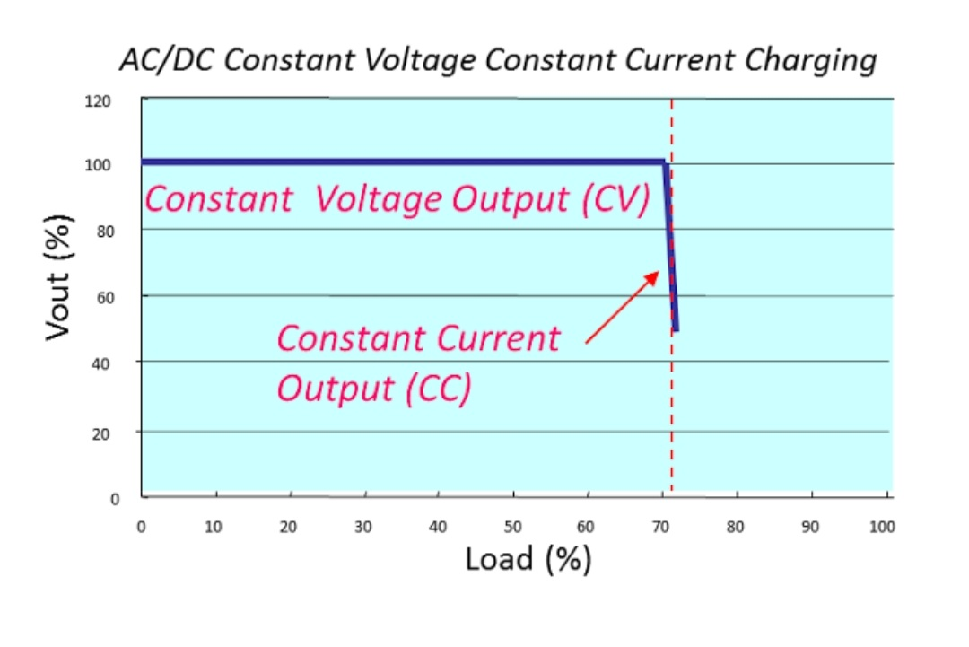

As an example, consider a 24V battery system (with a maximum float voltage of 28V) and discharged down to 15V
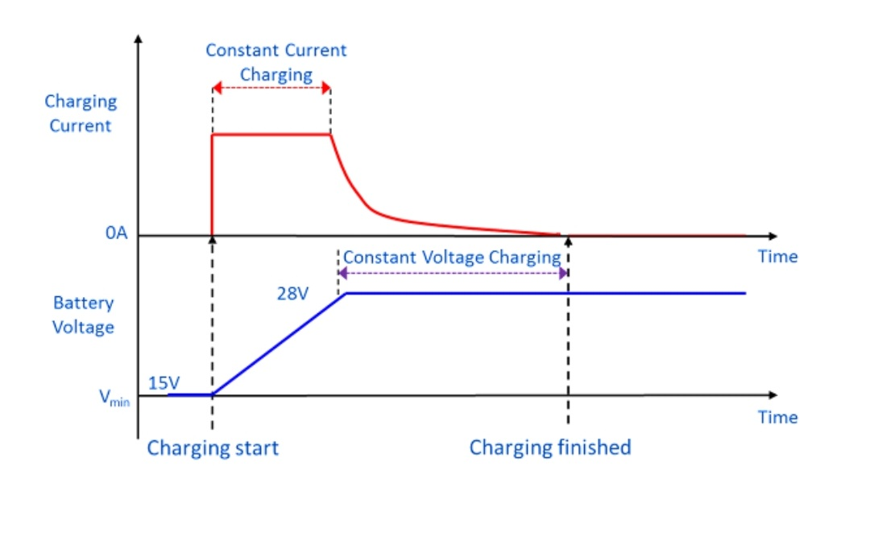

When the discharged battery (at 15V) is connected to the power supply, the battery will start to charge at the pre-set constant current level. The current will remain constant until the voltage rises to 28V. At this point the power supply will transition to constant voltage mode and the current will decay to zero when the battery is fully charged.

- Circuit Diagrams

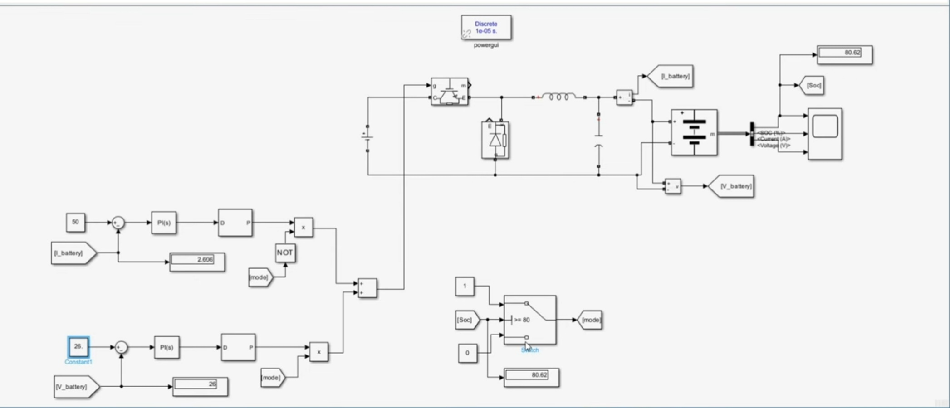

- Observations
. During the constant current phase, the battery voltage increases steadily while the current remains constant.
. As the battery reaches its target voltage, the system transitions to the constant voltage phase, where the voltage remains stable and the current gradually decreases.
. The transition between phases is smooth, minimizing stress on the battery and reducing the risk of overcharging.
. The charge current is controlled to avoid overheating and the float voltage limited to avoid over-charging.

- Analysis

1. Efficiency:
Shipping Stages:
i. DC Charging:
- Charging starts with a constant current until the battery reaches a certain voltage level.

ii. Continuous Voltage Charging:
- Maintains a constant voltage while gradually decreasing the current until it reaches a low level, indicating that charging is complete.

2. Battery Health:
- Smooth transition between phases reduces thermal stress and degradation, enhancing battery lifespan.
- Monitoring current and voltage helps in identifying any anomalies during charging.

3. Performance:
- The method provides a balanced approach, combining speed and safety.
- Simulink simulations offer insights into system behavior, allowing for adjustments to improve performance.

4. Optimization Opportunities:
- Parameter tuning in Simulink can optimize charging rates for different battery types.
- Analyzing simulation data helps in designing more efficient and robust charging systems.

- Calculation

The calculations for constant current and constant voltage charging, consider the following:

i. Constant Current Phase

1. Initial Parameters:
- I : Constant charging current (A)
- V_initial: Initial battery voltage (V)
- V_target: Target voltage for transition (V)
- C : Battery capacity (Ah)

2. Time to Reach Target Voltage:
T_CC= C × (V_target - V_initial) / I
- This formula assumes a linear voltage increase.

ii. Constant Voltage Phase

1. Parameters:
- V_constant: Voltage maintained during this phase (V)
- I_final: Final current when charging is complete (A)

2. Time to Full Charge:
- As the current decreases, the time can be estimated based on observed data or battery specifications.

iii. Total Charging Time

- The total time is the sum of both phases:
T_total= T_CC + T_CV
T_total= 10 + 4 = 14 Ah

Assume:
- I = 20 A
- Vinitial = 28.0 V
- Vtarget = 48 V
- C = 100Ah

iv. Constant Current Phase:
T_CC = 100× (48 - 28)}{20} = 10 hours,

vi. Constant Voltage Phase:
- Requires experimental data for precise time estimation, often a smaller fraction of T_CC; So the constant Voltage Phase well be almost =4

- Conclusion

. The combination of the two methods ensures that the battery is charged efficiently and safely.
. Reduces the chances of overcharging or overheating, conserving battery life

